

**MATHEMATICS  
APPLICATIONS**

**Test 2 – Sequences**

**Chapter 1 and 2**

**Semester 1 2018**

**Section One - Calculator Free**

Time allowed for this section

Working time for this section: 25 minutes

Marks available: 27 marks

## Material required/recommended for this section

##### To be provided by the supervisor

This Question/Answer booklet

Formula sheet

##### To be provided by the candidate

Standard items: pens, pencils, pencil sharpener, eraser, correction fluid, ruler, highlighters

Special items: Nil

## Important note to candidates

No other items may be used in this section of the examination. It is **your** responsibility to ensure that you do not have any unauthorised notes or other items of a non-personal nature in the examination room. If you have any unauthorised material with you, hand it to the supervisor **before** reading any further.

1. (2 marks)  
   Calculate the sum of all the multiples of 5 **between** 1 and 50.
2. (5 marks)A sequence of numbers is described by the recursive equation , where ** .**
   1. Determine   [1]
   2. Determine   [1]
   3. State a rule for the nth term of this sequence. [2]
   4. Determine   [1]
3. (5 marks)
   1. A sequence is defined by  , where ** .**
      1. State a rule for the nth term of this sequence in simplified form.[1]
      2. Determine   [1]
   2. The first-order recurrence relation  was used with  to calculate  and ****. Determine the values of *b, c* and **.** [3]
4. (8 marks)  
   The number of laptop computers, $T_{n}$, that were brought to a school IT department for recharging during week $n$ of the school year can be described recursively by the rule
$$T_{n+1}=T_{n}+3, T_{4}=16$$

5. Use the rule to complete the table below. [2]

|  |  |  |  |  |  |  |  |
| --- | --- | --- | --- | --- | --- | --- | --- |
| $$n$$ | 1 | 2 | 3 | 4 | 5 | 6 | 7 |
| $$T_{n}$$ |  |  |  |  |  |  |  |

1. Display the terms of the sequence from the table on the graph below. [2]

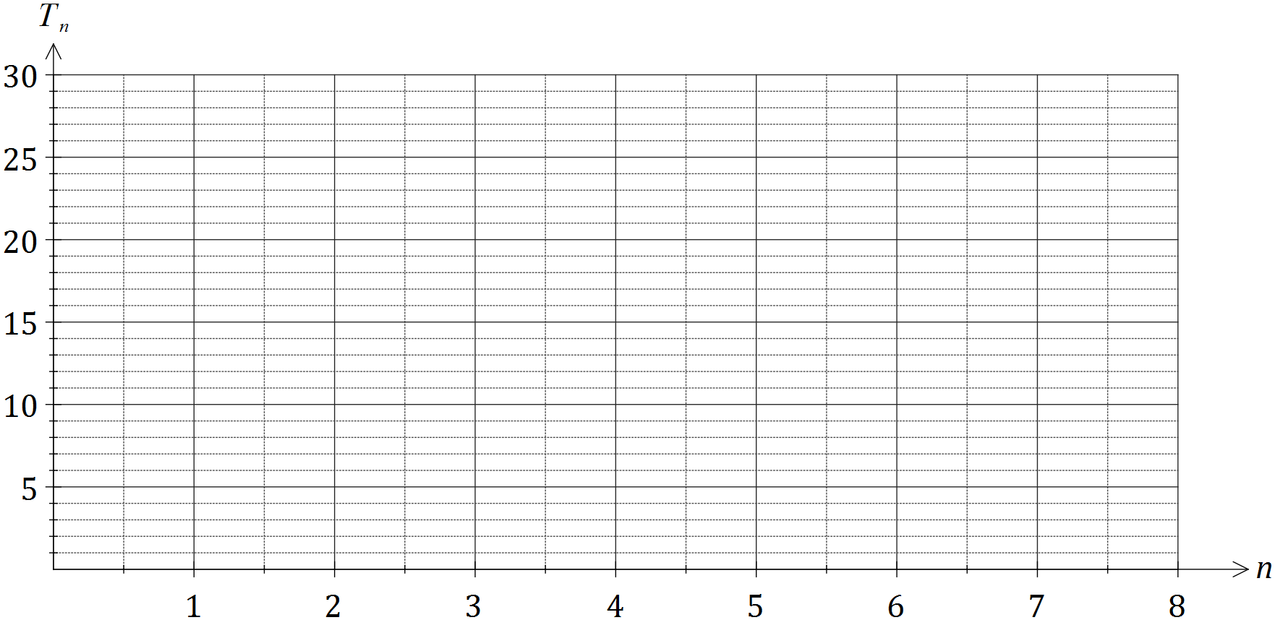

1. A rule to determine the number of laptops brought for recharging during week $n$ can also be written in the form $T_{n}=an+b$. Determine the values of $a$ and $b$. [2]
2. If the pattern continued, determine the number of the week during which the number of laptops brought in for recharging first exceeds 50. [2]
3. (7 marks)  
   The sixth term of an arithmetic sequence is double its fourth term. The first term of the sequence is 20 and the common difference is d.
   1. Show that [3]  
       

* 1. Hence, find the recursive rule for the sequence. [4]

Extra space for working if required

**End of Section One**